Dear Dad, 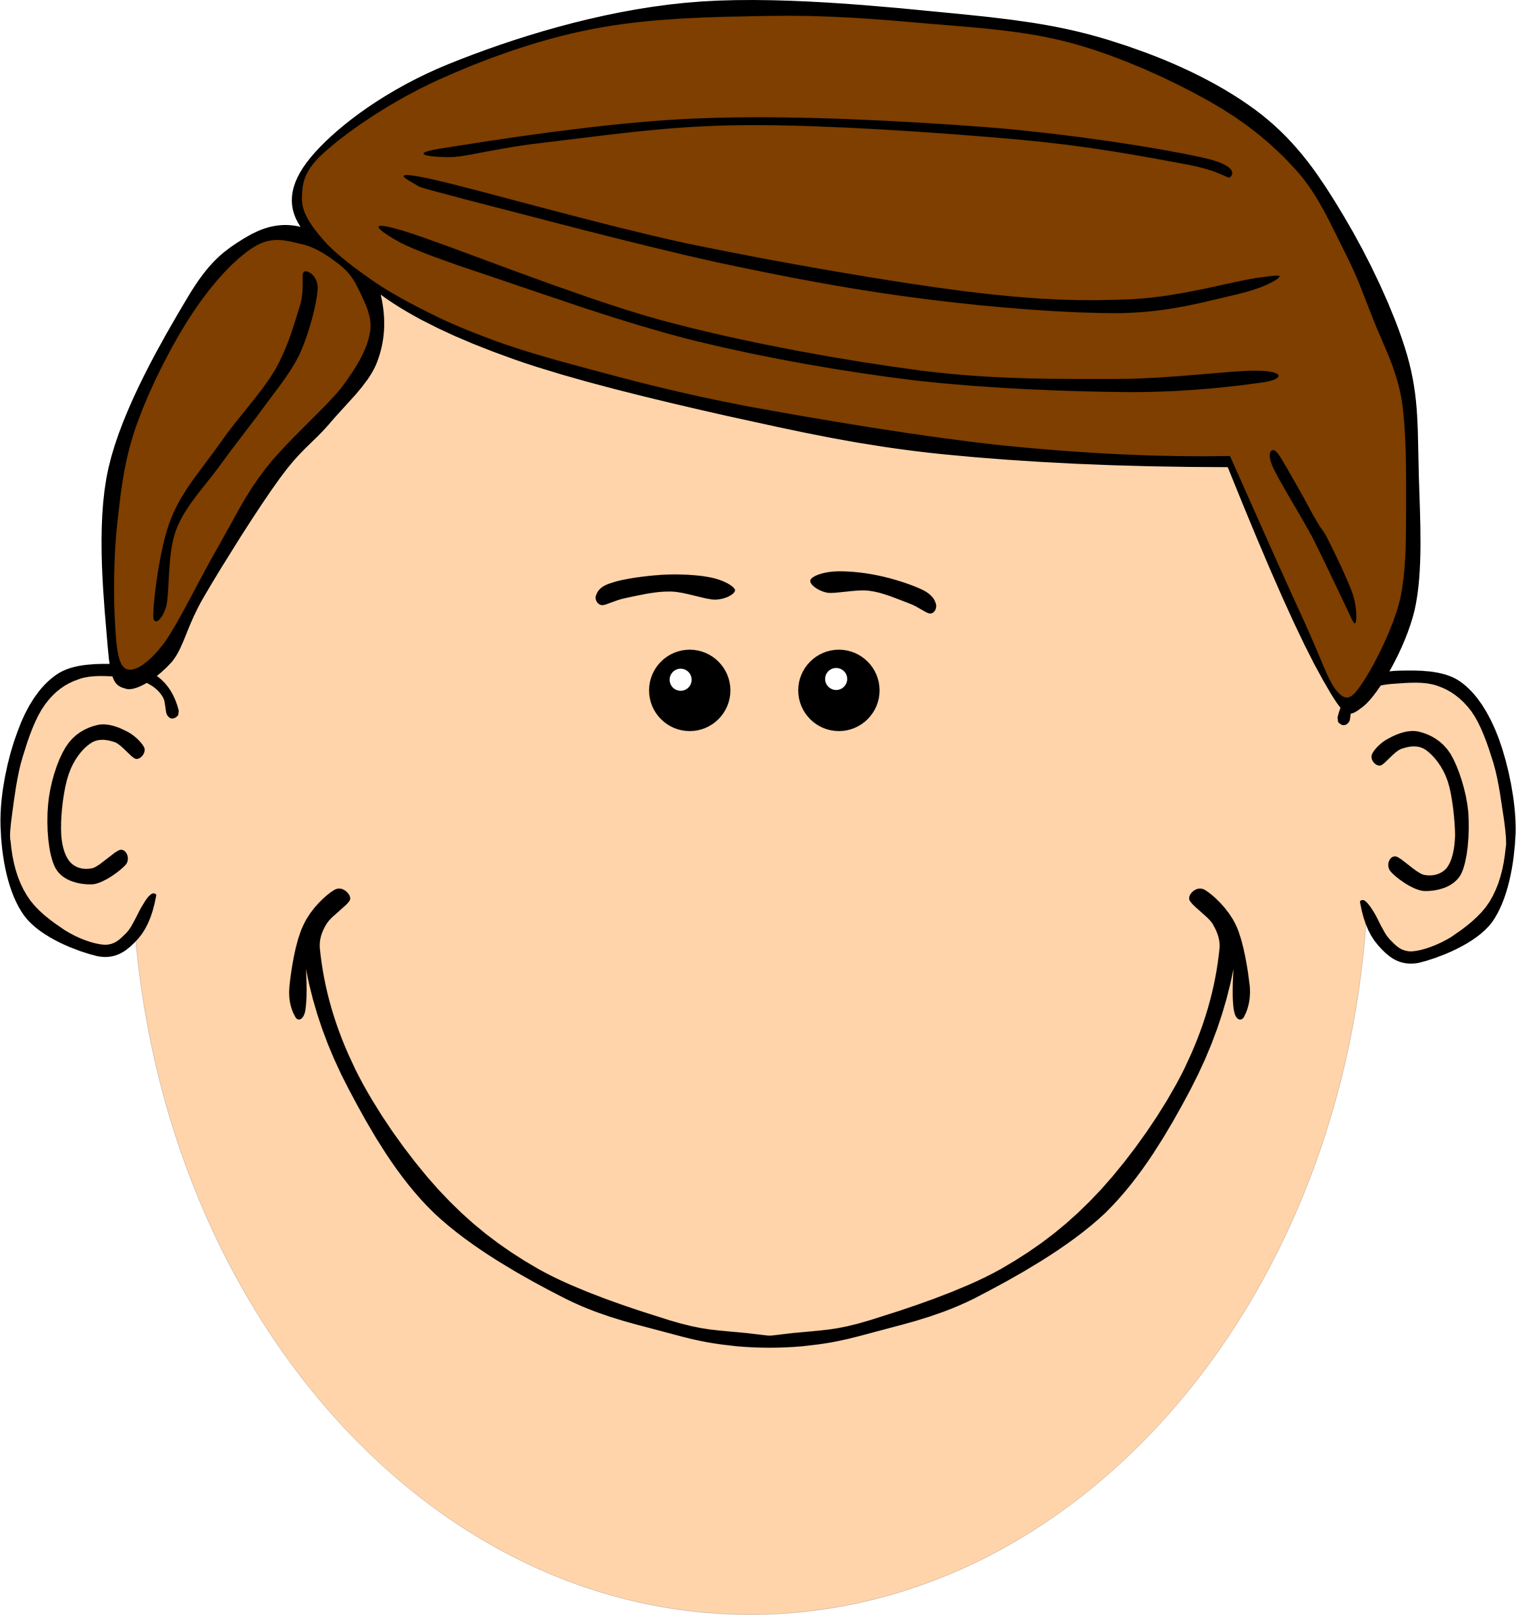

You have taught me…

I like it when you…

My favorite memory with you was when…

You are the best dad because…

I love you!
Happy Father’s Day!

Love,

